Supplementary Information
Supplementary tables

Table S1 Sequences of oligonucleotide primers required for quantitative PCR.
Target group | Primer name and sequence (5´-3´) | Approximate size (bp) of product | Annealing temp (℃) | Reference
Bacteria | Eub338F, ACTCCTACGGGAGGCAGCAG | 200 | 53 | Fierer et al. 2005
 | Eub518R, ATTACCGCGGCTGCTGG
Fungi | ITS1f, TCC GTA GGT GAA CCT GCG G | 300 | 53 | Fierer et al. 2005
 | 5.8s, CGC TGC GTT CTT CAT CG
Fusarium oxysporum | FOF1, ACATACCACTTGTTGCCTCG | 340 | 58 | Jiménez-Fernández et al. 2010
 | FOR1, CGCCAATCAATTTGAGGAACG
Pseudomonas | Ps-for, GAGTTTGATCCTGGCTCAG | 440 | 50 | Johnsen et al., 1999
 | Ps-rev, CCTTCCTCCCAACTT
Bacillus | Bs16S1, ATGTTAGCGGCGGACGGGTGAG | 500 | 60 | Mori et al., 2004
 | Bs16SR, AAGTTCCCCAGTTTCCAATGACC

Table S2 PERMANOVA results for bacterial and fungal community structure at the OTU level.
Soil  compartment | Main test ª | Bacteria |  |  |  | Fungi
Soil  compartment | Main test ª | PERMANOVA |  |  |  | PERMANOVA
Soil  compartment | Main test ª | F | P (>F) | R² |  | F | P (>F) | R²
Bulk soil | Treatment | 2.94 | 0.007 | 0.23 |  | 2.06 | 0.106 | 0.17
Bulk soil | Group | 2.94 | 0.007 | 0.23 |  | 2.18 | 0.093 | 0.18
Rhizosphere soil | Treatments | 2.47 | 0.038 | 0.20 |  | 1.42 | 0.217 | 0.12
Rhizosphere soil | Group | 2.47 | 0.034 | 0.20 |  | 1.13 | 0.319 | 0.10
Note: PERMANOVA, permutational multivariate analysis of variance. ª Main factor represent treatment (OF+W19, SOF+W19, OF, SOF), Group (group1 (OF+W19, SOF+W19), group2 (OF, SOF)). P-values were calculated based on 999 permutations (lowest P-value possible is 0.001). Values in table represent the pseudo-F ratio (F), the level of significance and the estimation of the variance component (R²) for PERMANOVA.

Table S3 Spearman's correlations between Fusarium wilt disease incidence and microbiota determined by Mantel test.
microbiota | Compartment | Mantel |  |  | PERMANOVA
microbiota | Compartment | R² | P |  | F | P(>F) | R²
Bacteria | Bulk | 0.195 | 0.07 |  | 2.489 | 0.016 | 0.199
Bacteria | Rhizosphere | 0.294 | 0.01 |  | 3.354 | 0.008 | 0.251
Fungi | Bulk | 0.171 | 0.08 |  | 1.593 | 0.194 | 0.137
Fungi | Rhizosphere | 0.005 | 0.42 |  | 1.168 | 0.307 | 0.105
Note: PERMANOVA, permutational multivariate analysis of variance. p-values were calculated based on 999 permutations (lowest P-value possible is 0.001). Values in table represent the pseudo-F ratio (F), the level of significance and the estimation of the variance component (R²) for PERMANOVA.

Supplementary Figures
Fig. S1. Linear regression between the abundances of cultivable and total F. oxysporum and relative abundance of Fusarium with disease incidence for bulk (A) and rhizosphere (B) soil.
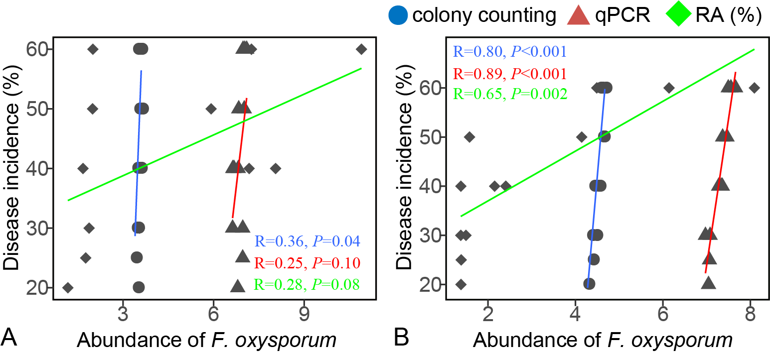
Note: Colony counting (lg CFU per gram soil), qPCR (lg copies per gram soil) and relative abundance (RA (%)).
Fig. S2. Cladogram showing phylogenetic relationships between 233 rhizosphere soil bacterial OTUs and their origin. Leaf labels indicate representative sequence IDs. Rings, from the inner to the outside circles, represent: (1) phylum-level taxonomy of OTU isolates (rainbow blocks); (2) OTUs responding significantly to the four treatments (LDA score value > 2); (3) Fold change of OTU isolates; (4) correlation between relative OTU abundance and disease incidence; and (5) Variable pattern of relative OTU abundance.
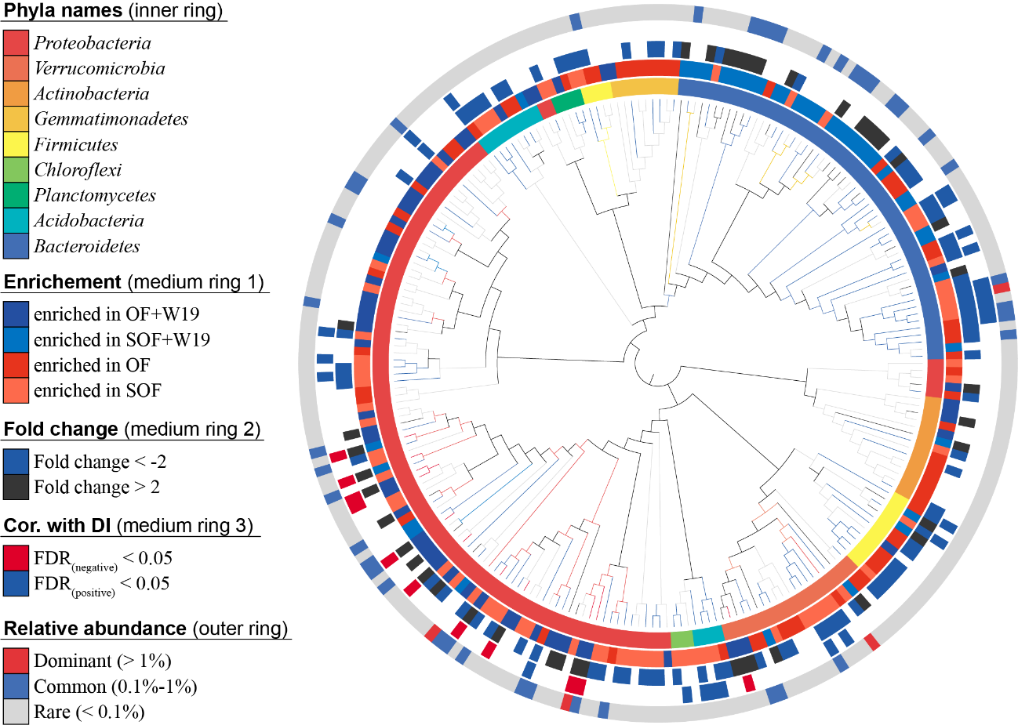
OF+W19 = Bio-organic fertilizer containing B. amyloliquefaciens W19, SOF + W19 = sterilized bio-organic fertilizer inoculated with B. amyloliquefaciens W19, OF = Organic fertilizer, SOF = Sterilized organic fertilizer.
Fig. S3. The abundance of total and cultivable Bacillus (A) and Pseudomonas (B) in banana bulk and rhizosphere soil.
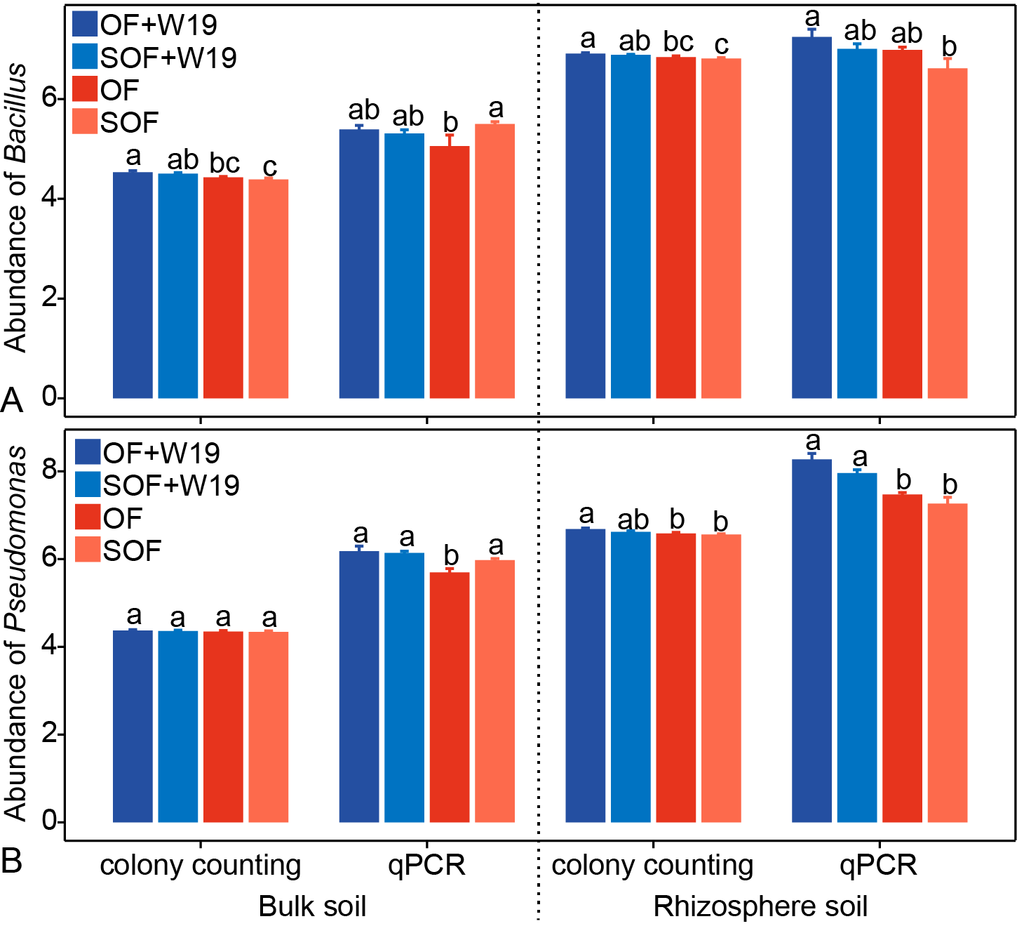
OF+W19 = Bio-organic fertilizer containing B. amyloliquefaciens W19, SOF + W19 = sterilized bio-organic fertilizer inoculated with B. amyloliquefaciens W19, OF = Organic fertilizer, SOF = Sterilized organic fertilizer. Different letters above the bars indicate a significant difference at the 0.05 probability level according to the Duncan test. Colony counting (lg CFU per gram soil), qPCR (lg copies per gram soil).

Fig. S4. Linear regression between the abundances of cultivable Bacillus and Pseudomonas in bulk soil (A) and rhizosphere soil (B).
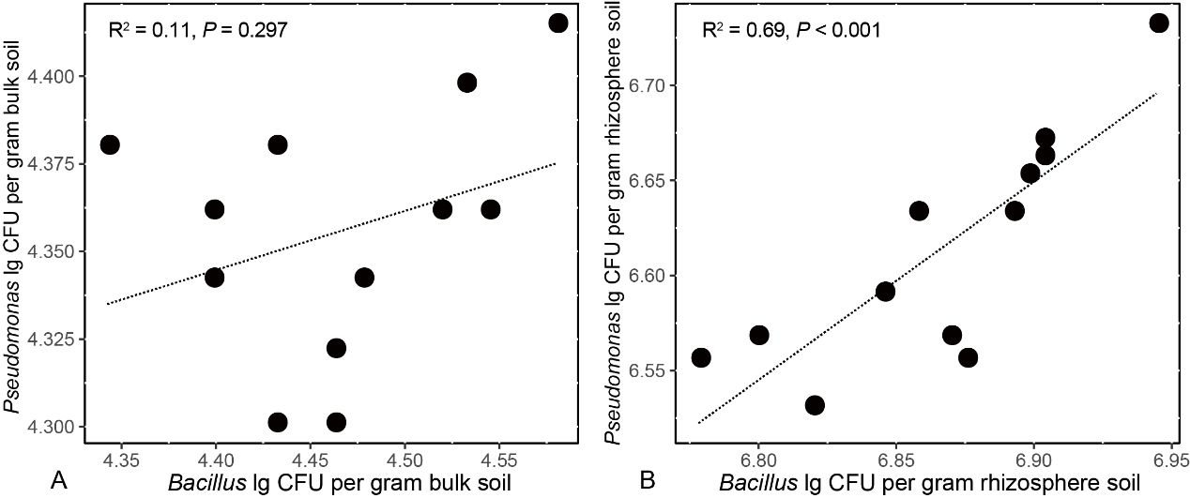

Fig. S5. Linear regression between the abundances of total and cultivable Bacillus (A, B) and Pseudomonas (C, D) with disease incidence for bulk and rhizosphere soil, respectively.
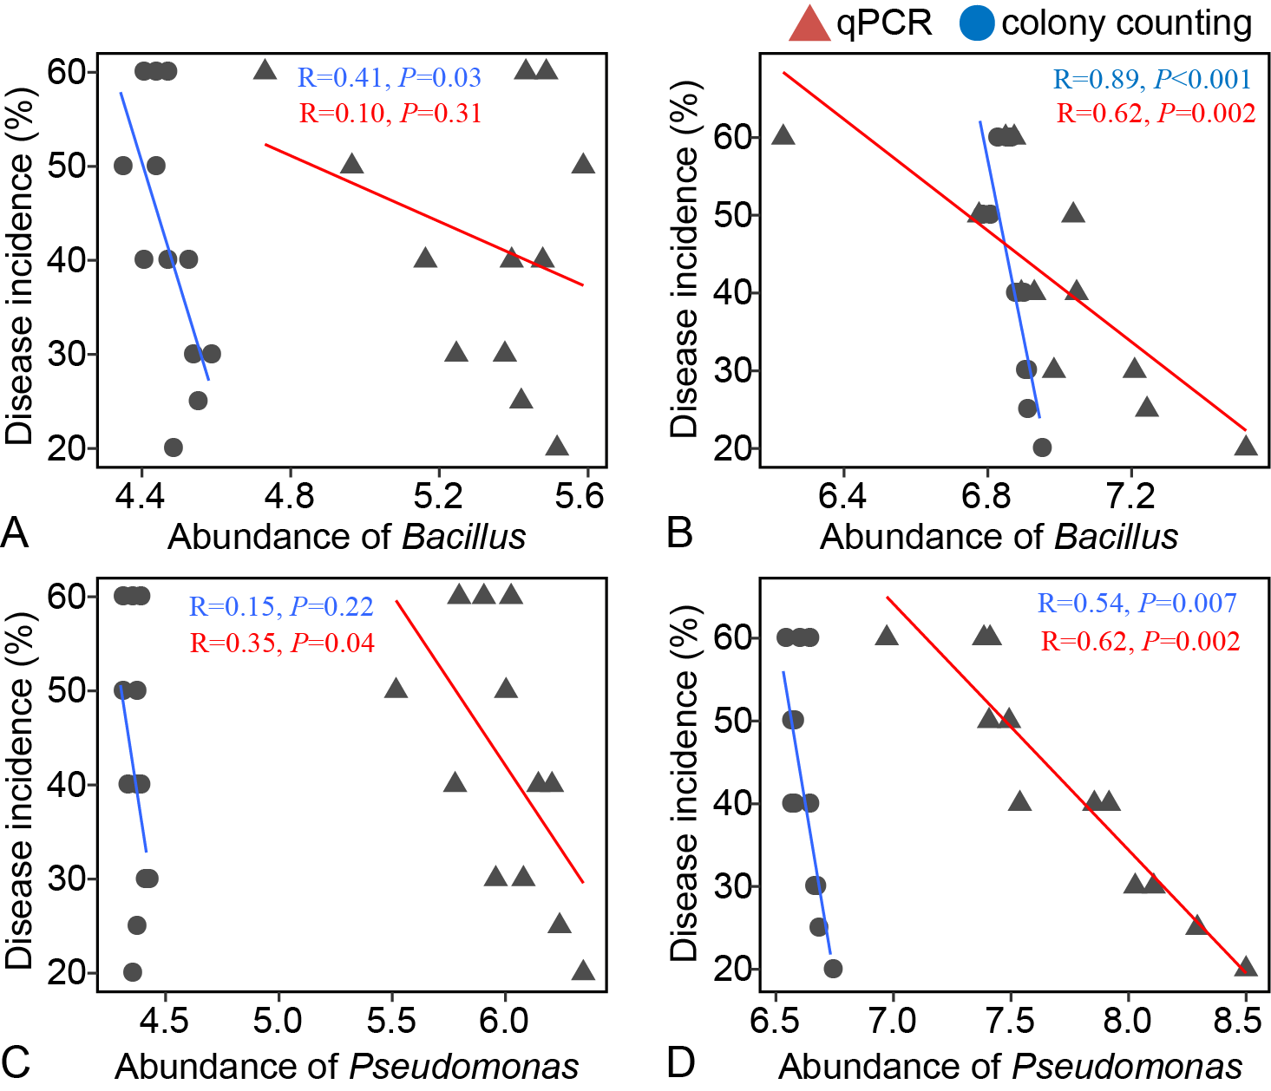
Note: Colony counting (lg CFU per gram soil), qPCR (lg copies per gram soil).

Fig. S6 (A) Biofilm formation of Pseudomonas isolates and B. amyloliquefaciens W19 in monocultures and Pseudomonas-Bacillus cocultures systems for isolates from OF+W19 and OF treatments; (B) Biofilm formation of Pseudomonas isolates and B. amyloliquefaciens W19 in monocultures and Pseudomonas-Bacillus cocultures systems; and (C) Biofilm formation of Pseudomonas isolates and B. amyloliquefaciens W19 in Pseudomonas-Bacillus cocultures systems for isolates from antagonistic group (antagonistic relationship between Pseudomonas spp. and W19) or non-antagonistic group (non-antagonistic relationship between Pseudomonas spp. and W19).
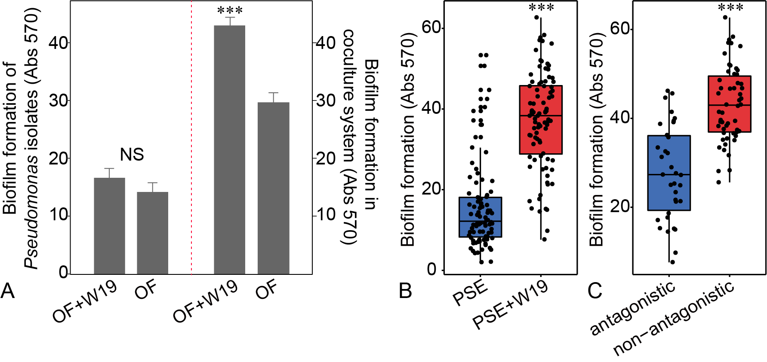
OF+W19 = Bio-organic fertilizer containing B. amyloliquefaciens W19, OF = Organic fertilizer. Wilcoxon-test, ***P < 0.001.

Fig. S7. Biofilm formation of Pseudomonas strain PSE78 or PSE82 with B. amyloliquefaciens W19 in monocultures and Pseudomonas-Bacillus co-culture systems (A). Pseudomonas-Bacillus-Fusarium oxysporum f. sp. cubense (FOC) interaction model (B). The interactions between Fusarium oxysporum f. sp. cubense (FOC), B. amyloliquefaciens W19 and Pseudomonas sp. PSE78 or PSE82 (C).
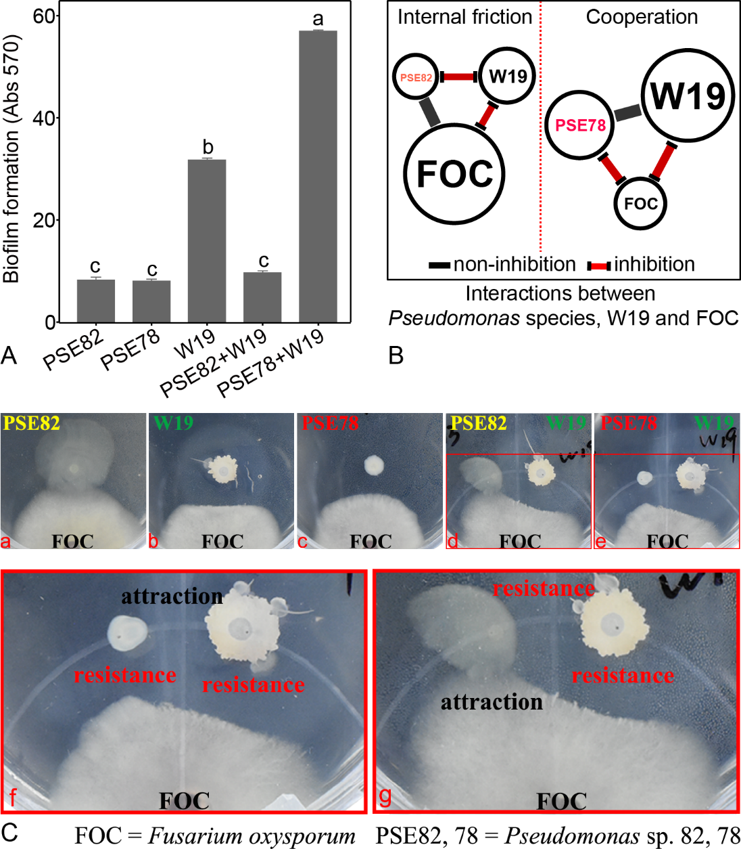
Note: Different letters indicate a significant difference at the 0.05 probability level according to the Duncan test.

Fig. S8. The abundance of total and cultivable F. oxysporum in banana bulk and rhizosphere soil treated with sterilized organic fertilizer inoculated with either Pseudomonas PSE78 or PSE82 as compared to sterilized organic fertilizer (SOF) and chemical fertilizer (CK) treatments.
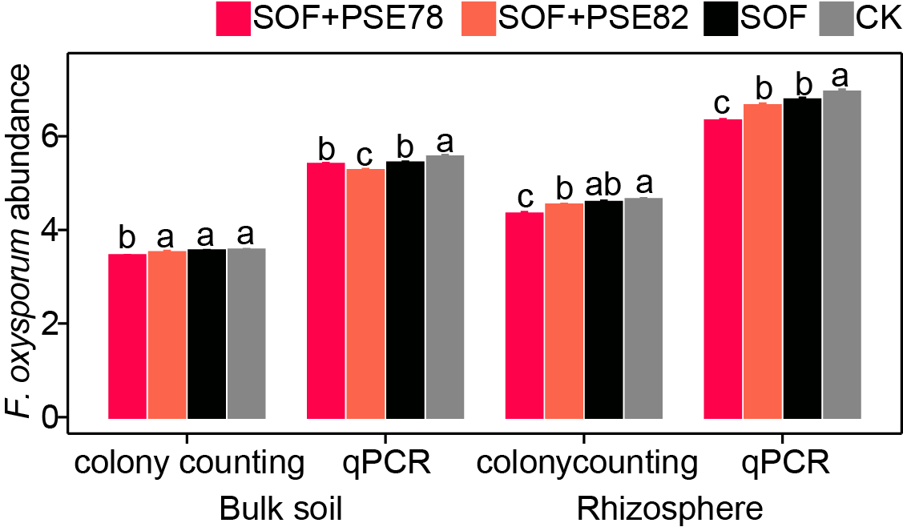
Note: Different letters above the bars indicate a significant difference at the 0.05 probability level according to the Duncan test. Colony counting (lg CFU per gram soil), qPCR (lg copies per gram soil).

Fig. S9. The abundance of total and cultivable Pseudomonas and Bacillus in banana bulk and rhizosphere soil treated with sterilized organic fertilizer inoculated with either Pseudomonas PSE78 or PSE82 as compared to sterilized organic fertilizer (SOF) and chemical fertilizer (CK) treatments.
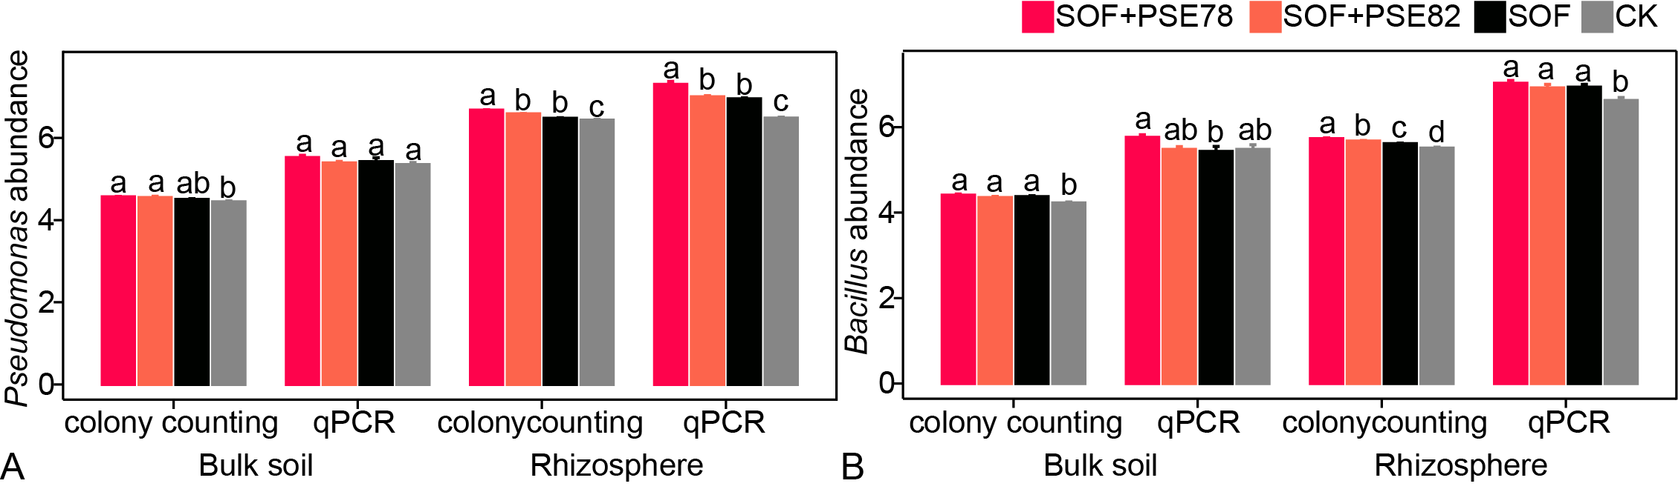
Note: Different letters above the bars indicate a significant difference at the 0.05 probability level according to the Duncan test. Colony counting (lg CFU per gram soil), qPCR (lg copies per gram soil).

Fig. S10. Linear regression between total and cultivable Fusarium, Pseudomonas and Bacillus with disease incidence in bulk soil (A, B, and C) and rhizosphere soil (E, F, and G). Linear regression between total and cultivable Bacillus and Pseudomonas in bulk soil (D) and rhizosphere soil (H).
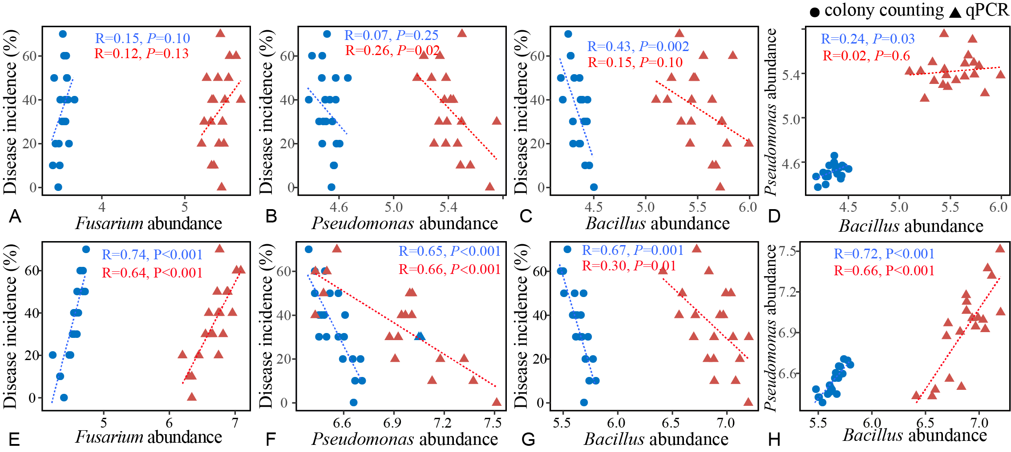
Note: Colony counting (lg CFU per gram soil), qPCR (lg copies per gram soil).

Fig. S11. Schematic representation of the experimental design for testing combined impacts of PSE strains and Bacillus amyloliquefaciens W19 on plant disease. (I) Sterile banana seedlings were inoculated with Bacillus amyloliquefaciens W19, Pseudomonas sp. PSE78 (PSE78), or Pseudomonas sp. PSE82 (PSE82), or a combination of W19 and PSE78 (W19+PSE78) or W19 and PSE82 (W19+PSE82) or mock treated (Control). (II) Thirty days after inoculation, all plants were transplanted into a new sterile substrate, (III) after which the banana plants were either inoculated with Fusarium oxysporum f. sp. cubense (FOC) spore suspension or given a mock inoculation. Disease severity was quantified by counting the number of FOC that colonized on plant roots after 3 weeks of inoculation.
